# 4. Stock Maintenance System

USECASE DIAGRAM

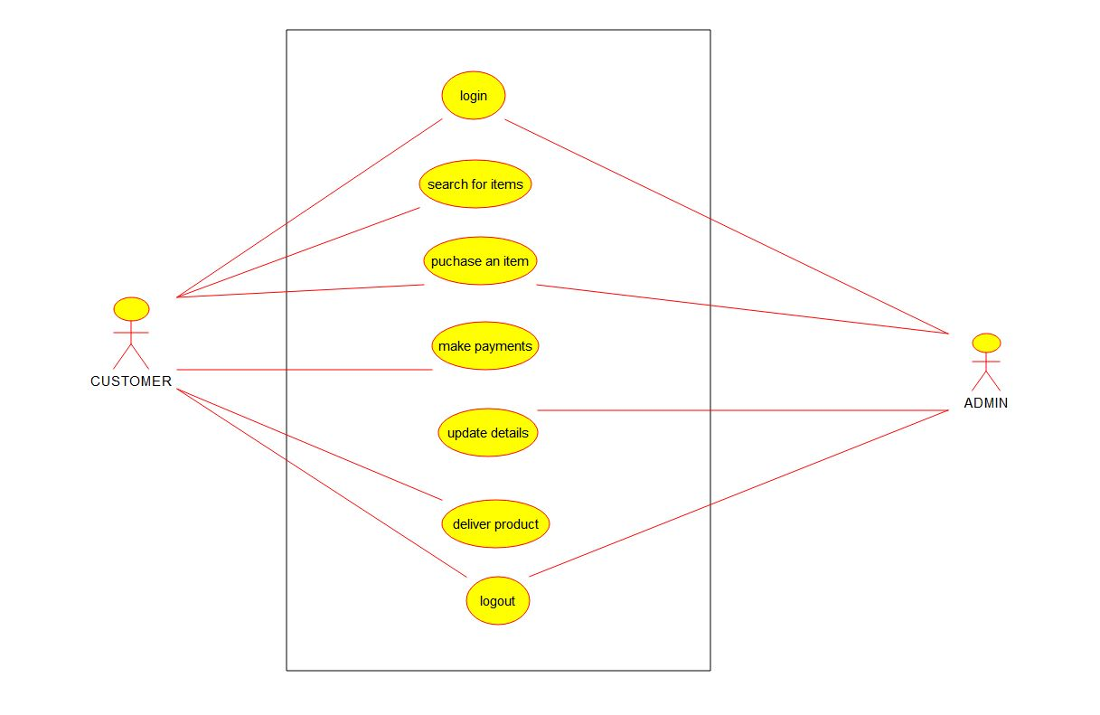

STATE DIAGRAM

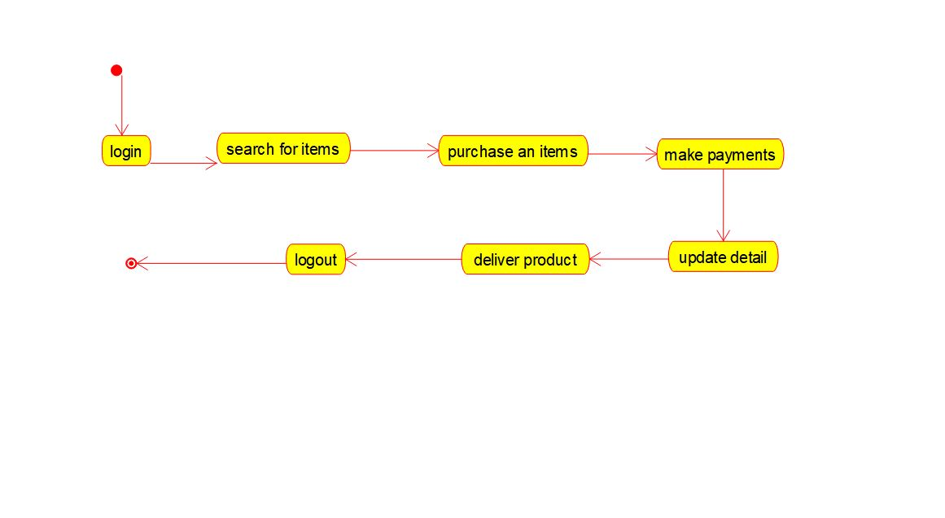

ACTIVITY DIAGRAM

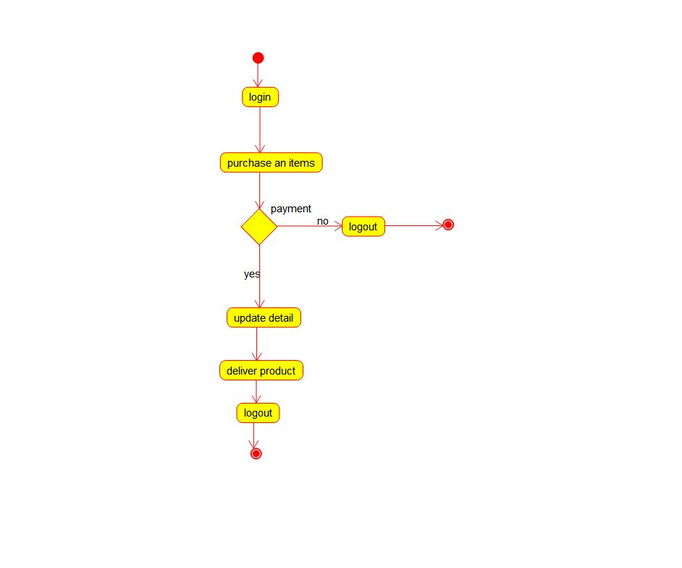

# 5. Online Course Reservation System

USECASE DIAGRAM

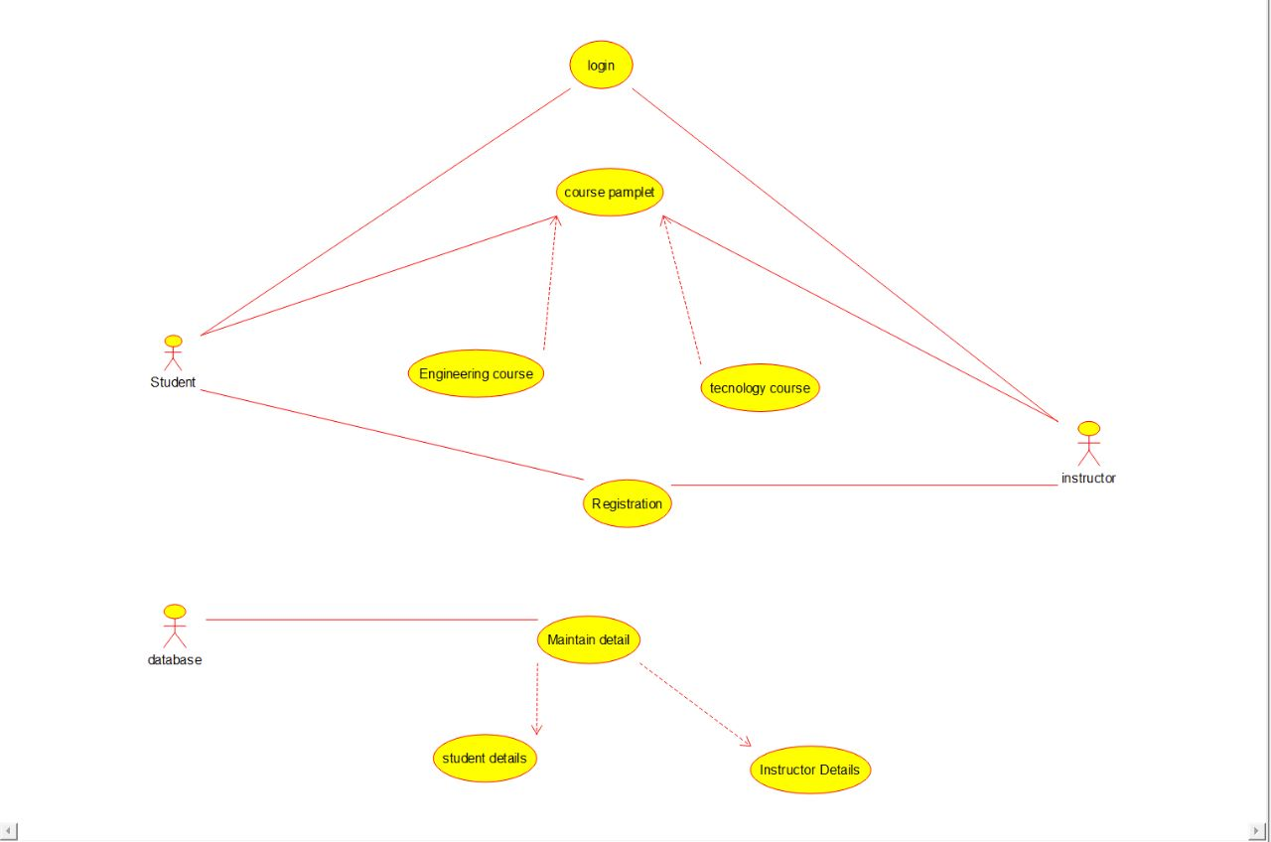

ACTIVITY DIAGRAM

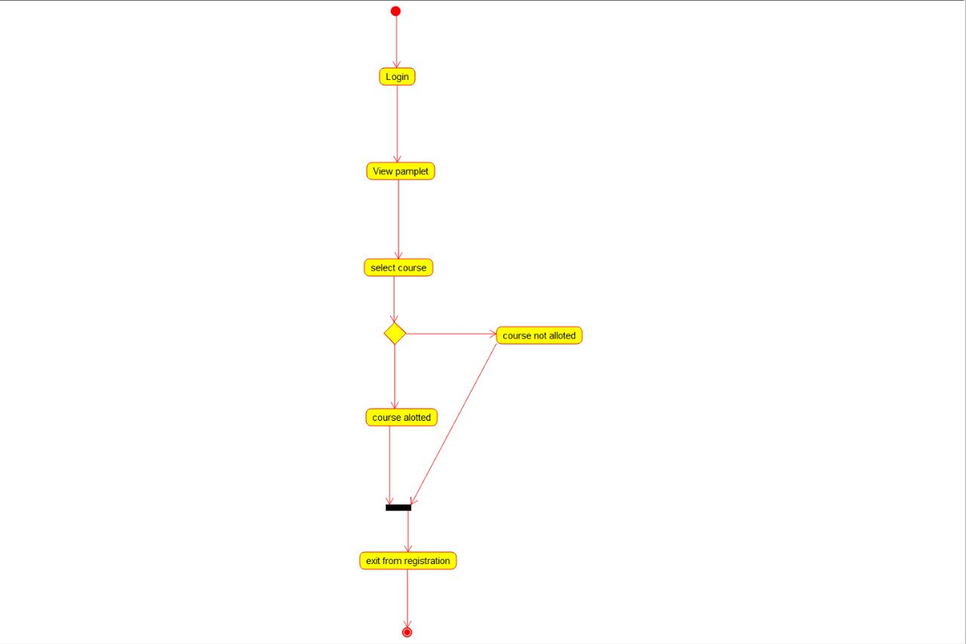

DEPLOYMENT DIAGRAM

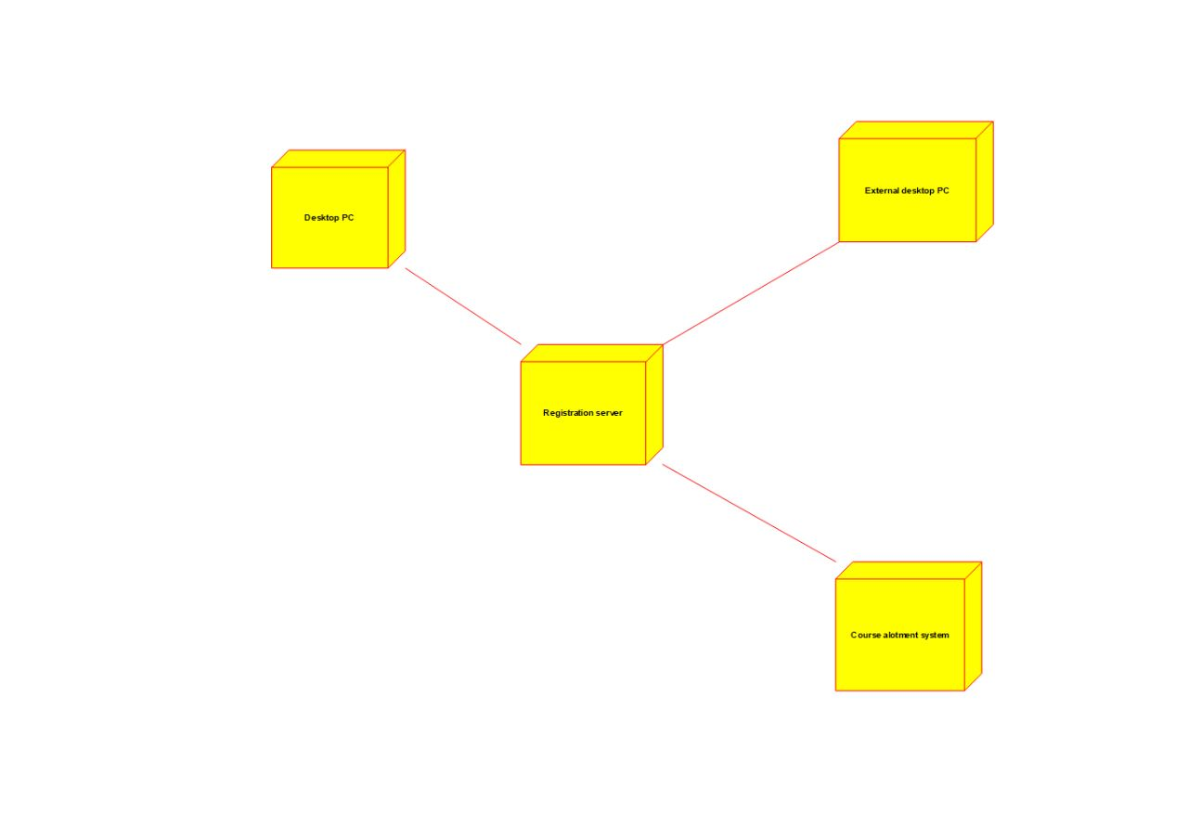

# 6. E-Ticketing System

USECASE DIAGRAM

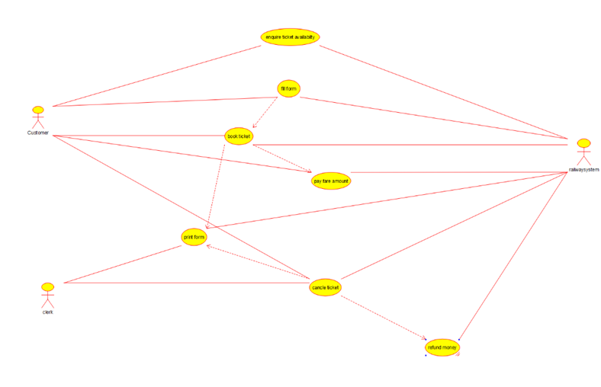

CLASS DIAGRAM

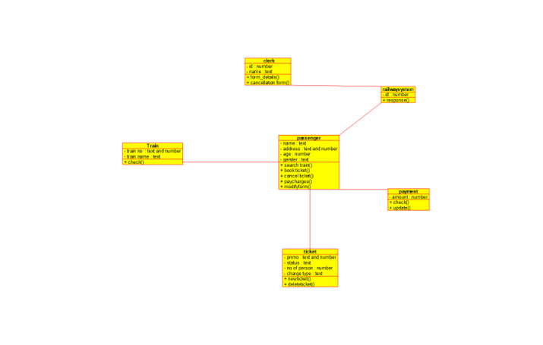

ACTIVITY DIAGRAM

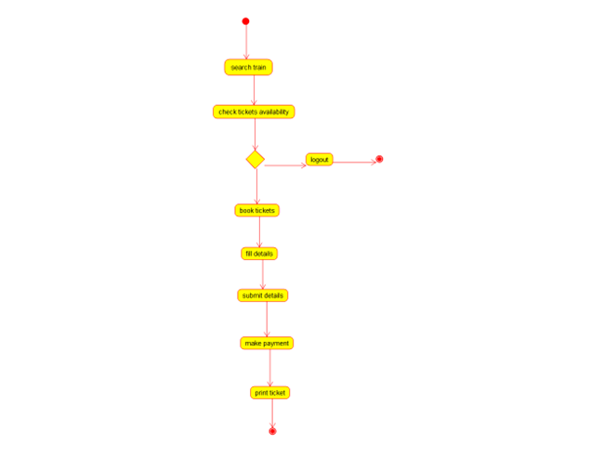

# 7. Credit Card Processing System

USE CASE DIAGRAM

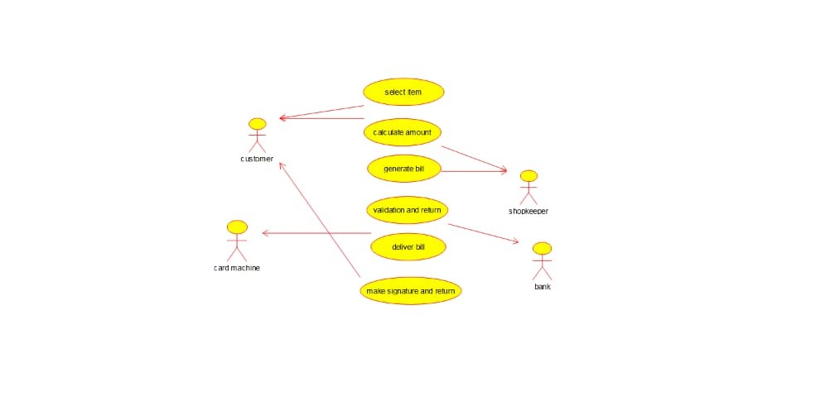

COMPONENT DIAGRAM

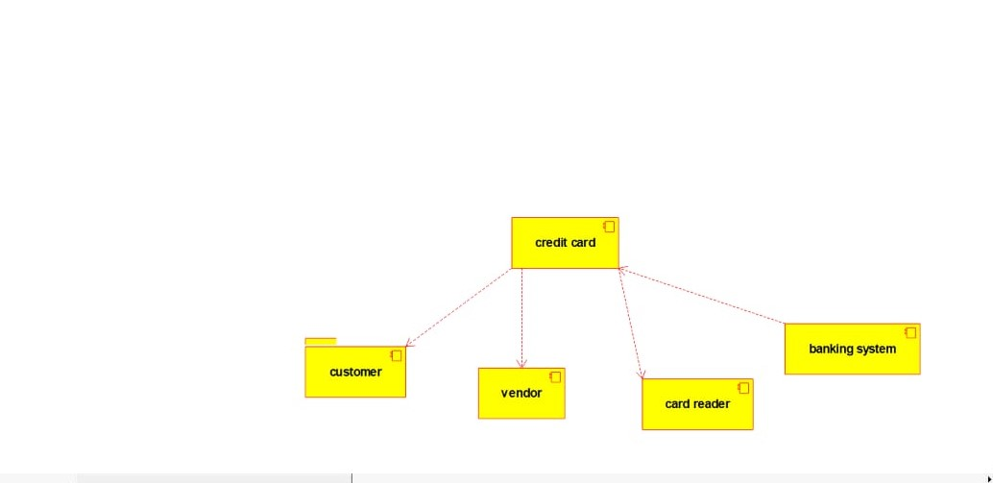

STATE DIAGRAM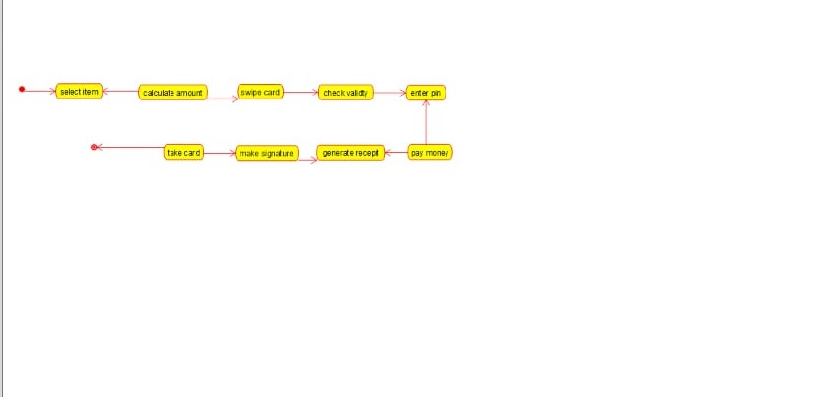

# Software Personnel Management System.

USECASE DIAGRAM

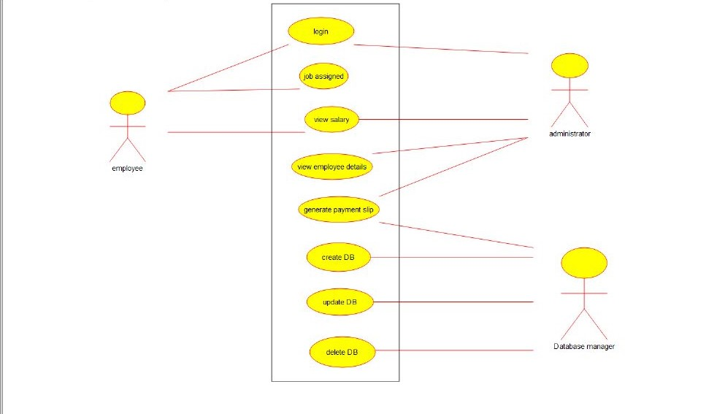

CLASS DIAGRAM

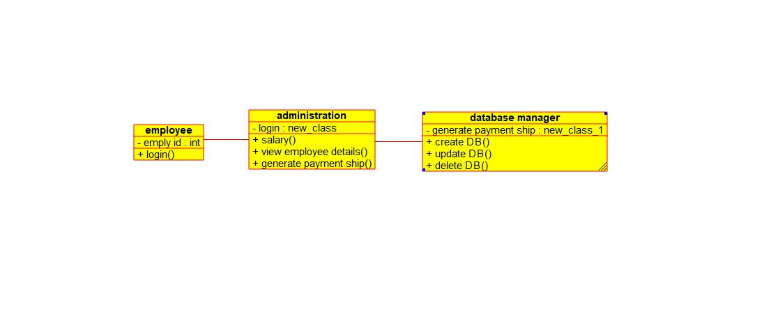

ACTIVITY DIAGRAM

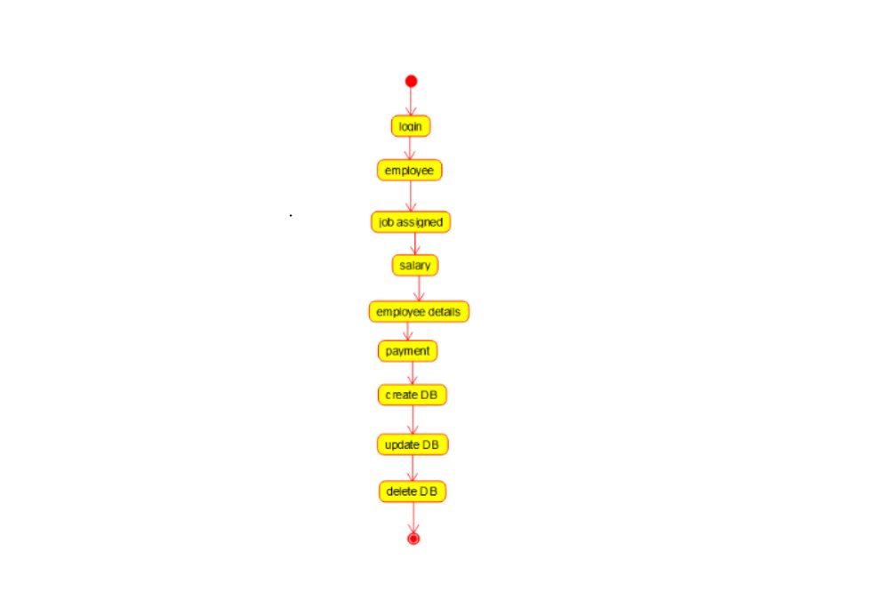

# 9.E book management

ACTIVITY DIAGRAM



CLASS DIAGRAM

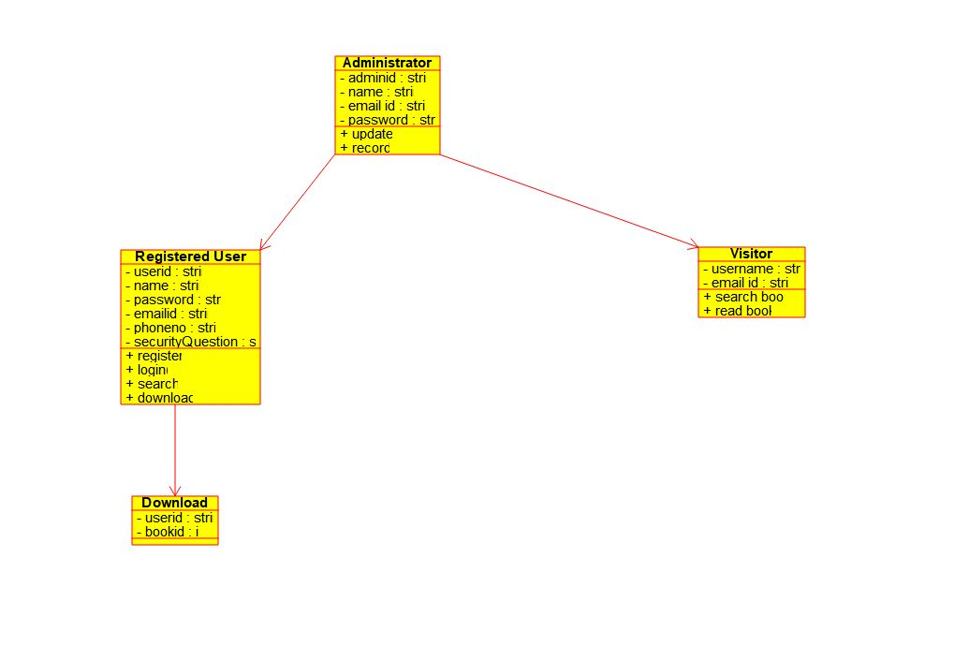

COLLABRATION DIAGRAM,

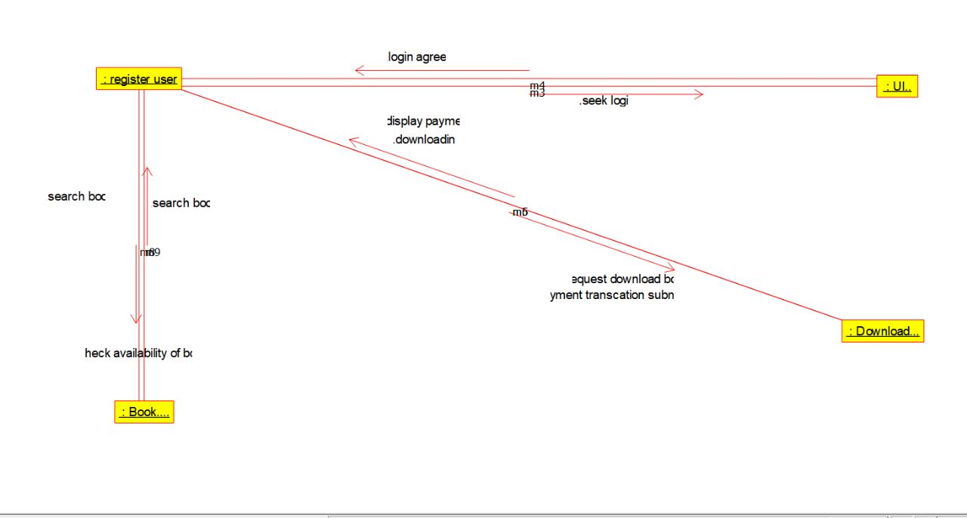

SEQUENTIAL DIAGRAM

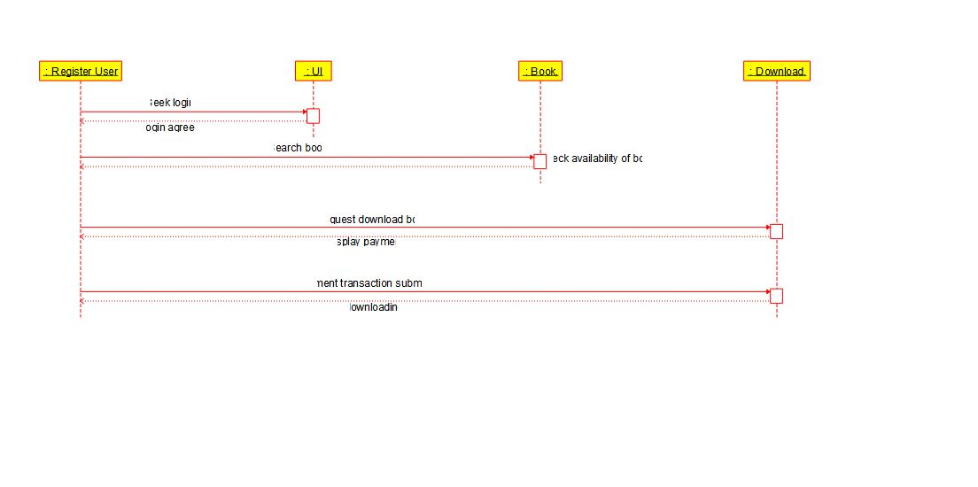

# 10. Recruitment System.

USE CASE DIAGRAM

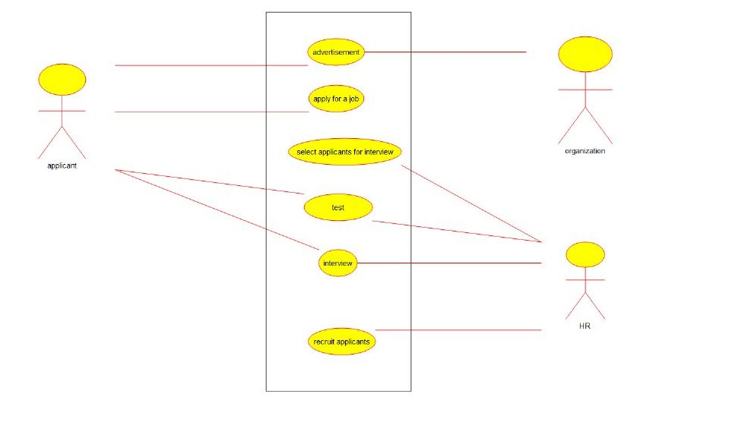

ACTIVITY DIAGRAM

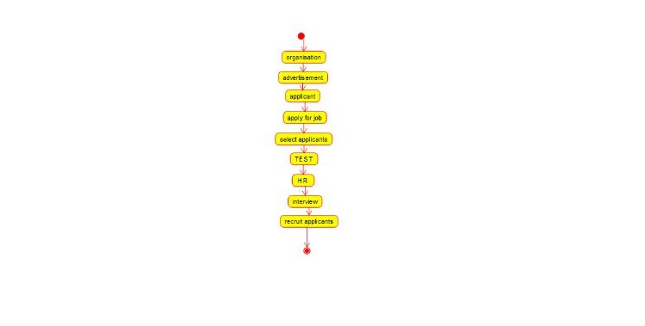

CLASS DIAGRAM

